How to connect MongoDB and Node Js
- Create the StudentApp folder in your desktop.
- Then using that path and go to command prompt
- In command Prompt we want to install the following parts
- npm init
- npm install
- npm install nodemon
- npm install mongoose

- After we install previous part we can find the following files and folder
- Package
- Package_lock
- node_modules
- Then we enter the code . in cmd ,we can redirect the text editor
- In the text editor ,we create the basic 3 .js files
- 1st index.js
- 2nd inside the one folder create the Course.js
- 3rd inside the another folder create the CourseRoute
- After enter the codes we can run the code in terminal part
- npm start
- Terminal show the output like this
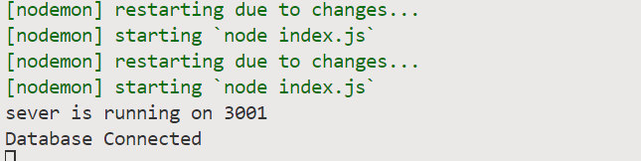
Int the postman output is
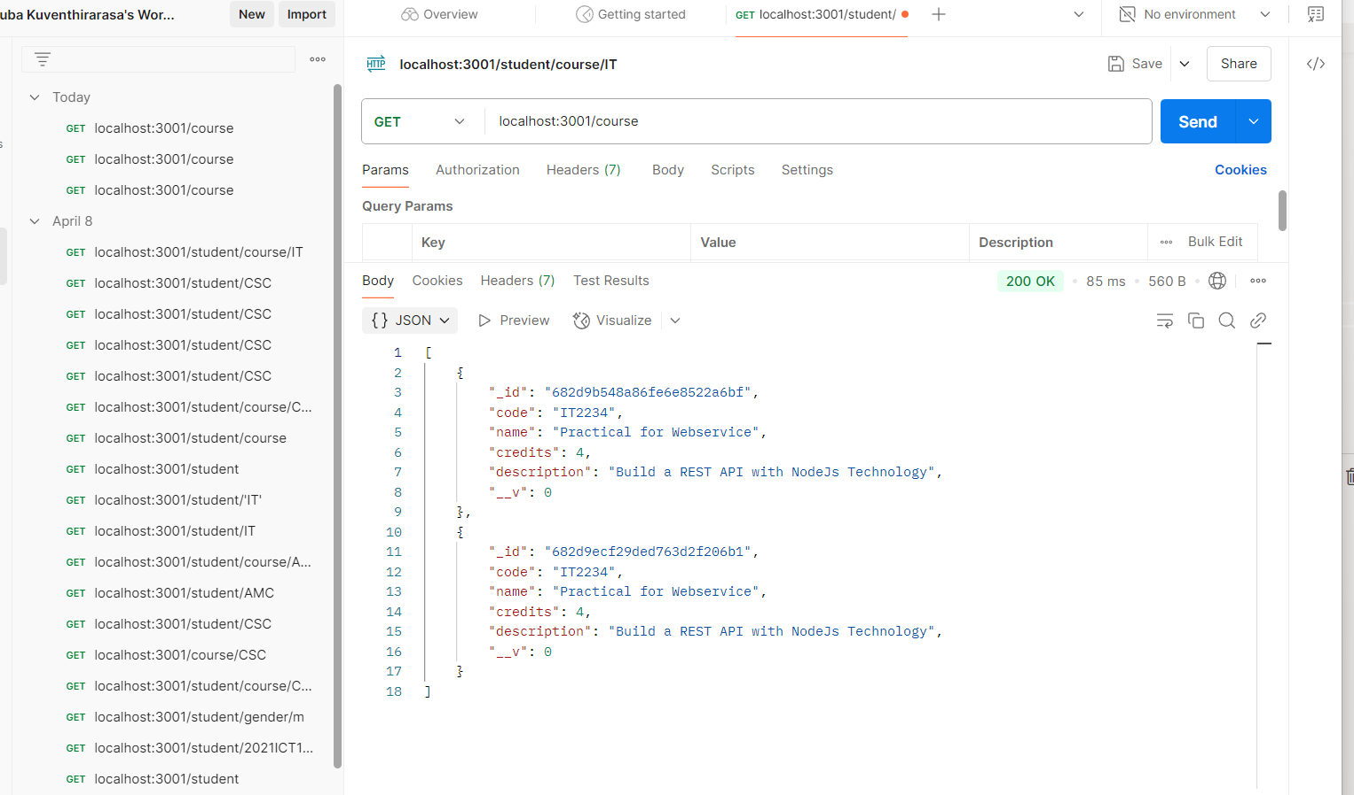

In the MongoDB output for create the database

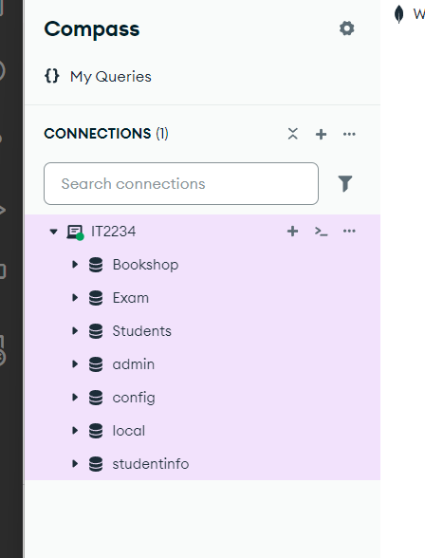
In the MongoDB Course collection
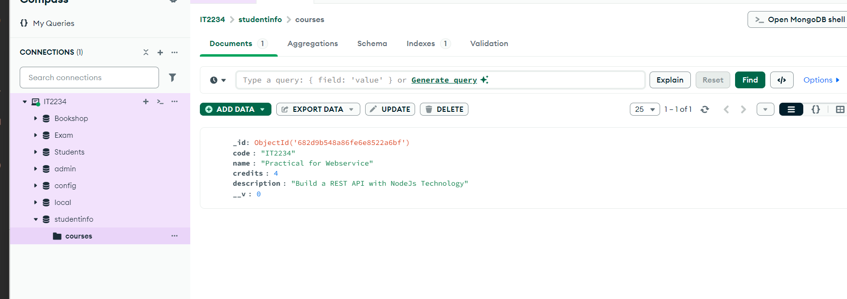
Using the course code we can able to find the Course is available or not

In the postman output is
